 

AUTOMATION OF MESSAGE SENDING PROCESS USING RPA BLUEPRISM

# A PROJECT REPORT

***Submitted by***

|  |  |
| --- | --- |
| **HARINI S** | **(211519104051)** |
| **SRUTHI B** | **(211519104160)** |
| **SUJITHA S** | **(211519104162)** |

***in partial fulfilment for the award of the degree***

***of***

# BACHELOR OF ENGINEERING IN

**COMPUTER SCIENCE AND ENGINEERING**

# PANIMALAR INSTITUTE OF TECHNOLOGY, POONAMALLEE

**ANNA UNIVERSITY: CHENNAI-600025**

# MAY 2023

 

ANNA UNIVERSITY: CHENNAI-600 025

**BONAFIDE CERTIFICATE**

Certified that this project report **“ AUTOMATION OF MESSAGE SENDING PROCESS USING RPA BLUEPRISM”** is the bonafide work of **“ HARINI S (211519104051), SRUTHI B (211519104160), SUJITHA S (211519104162) ”**who carried out the project work under my supervision.

|  |  |
| --- | --- |
| **SIGNATURE** | **SIGNATURE** |
| Dr.V.SUBEDHA, M.Tech., PH.D., | Dr.W.GRACY THERESA, M.E,PH.D., |
| Professor and Head | Professor |
| Department of CSE,  Panimalar Institute of Technology, | Department of CSE,  Panimalar Institute of Technology, |
| Poonamallee, Chennai-600123. | Poonamallee, Chennai-600123. |

Certified that the above candidates were examined in the university project work viva-voce examination held on at Panimalar Institute of Technology, Chennai- 600123.

# INTERNAL EXAMINER EXTERNAL EXAMINER

**ACKNOWLEDGEMENT**

We wish to express our sincere thanks to all those who were involved in the completion of this project.

We would like to express our deep gratitude to our beloved **Secretary and Correspondent, Dr. P. CHINNADURAI, M.A., M.Phil., Ph.D.,** for his kind words and enthusiastic motivation.

We also express our sincere thanks and gratitude to all our dynamic **Directors Mrs.**

# C. VIJAYA RAJESHWARI, Dr. C. SAKTHIKUMAR, M.E., Ph.D., and Dr. SARANYASREE

**SAKTHIKUMAR, B.E., M.B.A, Ph.D.,** for providing us infrastructure required to carry out this project.

We also express our appreciation and gratefulness to our respected **Principal Dr. T. JAYANTHY, M.E., Ph.D.,** for her thoughtful cooperation and encouragement.

We wish to convey our thanks and gratitude to our **Professor and Head of the Department, Dr. V. SUBEDHA, M. Tech., Ph.D.,** for her valuable guidance and excellent support.

Special thanks to our Supervisor **Dr. W. GRACY THERESA, M.E, PH.D, Professor**, Computer Science and Engineering for her technical expertise and domain knowledge for successful completion of this project.

Last but not the least we place a deep sense of gratitude to our family members and our friends who have been constant source of inspiration during the preparation of this project work.

# ABSTRACT

Automating the sending congratulatory messages and images to colleagues in the WhatsApp messenger using its web version “WhatsApp Web” due to the lack of an official API for creating bots. In the modern world, we often face the problem of lack of time. Each person has to do many different things every day. Therefore, sometimes people forget about the important thing about maintaining a connection. Indeed, it takes a significant amount of time to pay attention to everyone. Because of this, people rarely write to each other, and sometimes they completely forget to congratulate a colleague on an important holiday for him. To get rid of the daily time spent, it was decided to create a program that would send cards to colleagues on holidays, birthdays, anniversaries and could also interact with them using command. The replies are sent out automatically without needing any human intervention by bot. WhatsApp automated messages are pre-set replies to messages received from new or existing customers on WhatsApp. This feature gives you the bandwidth to respond to customer messages even outside of business hours. The promptness and efficiency with which customers receive responses from your business are bound to improve their satisfaction. The aim of this research project is to propose an end-to-end model for human activity recognition.

# TABLE OF CONTENTS

|  |  |  |  |  |
| --- | --- | --- | --- | --- |
| **CHAPTER NO.** |  |  | **TITLE** | **PAGE NO.** |
| **ABSTRACT** i | | | | |
| **LIST OF FIGURES** ii | | | | |
| **LIST OF SYMBOLS** v | | | | |
| **LIST OF ABBREVIATION** vi | | | | |
| **1** | **INTRODUCTION** | | | 01 |
|  | 1.1 | Scope of the Project | | 01 |
| **2** | **LITERATURE SURVEY** | | | 02 |
| **3** | **SYSTEM STUDY** | | | 10 |
|  | 3.1 | Existing System | | 10 |
|  |  | 3.1.1 | Disadvantages | 10 |
|  | 3.2 | Proposed System | | 11 |
|  |  | 3.2.1 | Advantages | 12 |
| **4** | **SYSTEM SPECIFICATION** | | | 13 |
|  | 4.1 | System Configuration | | 13 |
|  |  | 4.1.1 | Hardware System Configuration | 13 |
|  |  | 4..1.2 | Software System Configuration | 13 |
|  | 4.2 | Blue Prism | | 14 |
| **5** | **SYSTEM DESIGN** | | | 15 |
|  | 5.1 | System Architecture | | 15 |
|  | 5.2 | Architecture Diagram | | 16 |
|  | 5.2 | UML Diagrams | | 12 |
|  |  | 5.2.1 | Use Case Diagram | 17 |
|  |  | 5.2.2 | Class Diagram | 18 |
|  |  | 5.2.3 | Activity Diagram | 19 |
|  |  | 5.2.4 | Sequence Diagram | 20 |
|  |  | 5.2.5 | E-R Diagram | 21 |

|  |  |  |  |  |
| --- | --- | --- | --- | --- |
| **6** | **SYSTEM IMPLEMENTATION** | | | 22 |
|  | 6.1 | General |  | 22 |
|  | 6.2 | Modules | | 26 |
|  | 6.3 | Modules Explanation | | 26 |
|  |  | 6.3.1 | Data Pre-Processing | 26 |
|  |  | 6.3.2 | Bot Logic | 27 |
|  |  | 6.3.3 | A* Algorithm | 27 |
|  |  | 6.3.4 | D* Algorithm | 28 |
|  |  | 6.3.5 | Deployment | 29 |
|  |  | 6.3.6 | Result and Discussion | 29 |
| **7** | **TESTING** |  |  | 25 |
|  | 7.1 | Types of Testing | | 31 |
|  |  | 7.1.1 | Unit Testing | 31 |
|  |  | 7.1.2 | Integration Testing | 32 |
|  |  | 7.1.3 | Functional Testing | 32 |
|  |  | 7.1.4 | White Box Testing | 32 |
|  |  | 7.1.5 | Black Box Testing | 33 |
|  | 7.2 | Testing Strategy | | 34 |
| **8** | **CONCLUSION** | | | 35 |
|  | 8.1 | Conclusion | | 35 |
|  | 8.2 | Future Enhancement | | 35 |
|  | **APPENDIX** | |  | 37 |
|  | **REFERENCES** | | | 54 |

**LIST OF FIGURES**

|  |  |  |
| --- | --- | --- |
| **FIGURE NO.** | **TITLE** | **PAGE NO.** |
| 5.1 | System Architecture | 15 |
| 5.2 | Architecture Diagram | 16 |
| 5.3 | Use Case Diagram | 17 |
| 5.4 | Class Diagram | 18 |
| 5.5 | Activity Diagram | 19 |
| 5. | Sequence Diagram | 20 |
| 5.7 | E-R Diagram | 21 |
| 6.1 | Blue Prism | 22 |
| 6.2 | Benefits of RPA | 23 |
| 7.1 | Black Box Testing | 33 |
| 9.1 | Bot launches and stores the data | 37 |
| 9.1.1 | Spying the messages | 38 |
| 9.1.2 | Blue Prism Memory | 39 |
| 9.1.3 | Storing Birthday Messages | 40 |
| 9.1.4 | Database 1 | 40 |
| 9.1.5 | Storing Work Anniversary Messages | 41 |
| 9.1.6 | Database | 42 |
| 9.1.7 | Storing in Excel Sheet | 42 |
| 9.1.8 | Process flow 1 | 43 |
| 9.1.9 | Process flow 2 | 43 |
| 9.2.0 | Excel sheet 1 | 44 |
| 9.2.1 | Excel sheet 2 | 44 |
| 9.2.2 | Excel sheet 1 | 45 |
| 9.2.3 | Excel sheet 2 | 46 |
| 9.3 | Process 2 | 47 |
| 9.3.1 | Flow of process 2 | 48 |
| 9.3.2 | Excel sheet 1 | 49 |
| 9.3.3 | Excel sheet 2 | 49 |
| 9.3.4 | Occasion holidays | 50 |
| 9.3.5 | Bot sends message | 51 |
| 9.4.1 | Message 1 | 52 |
| 9.4.2 | Message 2 | 52 |
| 9.4.3 | Message 3 | 53 |
| 9.4.4 | Message 4 | 53 |

# LIST OF SYMBOLS

|  |  |  |  |  |  |
| --- | --- | --- | --- | --- | --- |
| **S.NO** | **SYMBOL** | **NOTATION** | | | **DESCRIPTION** |
| 1 | Actor |  | | | Specifies the role played by a user or any other system that interacts with the  subject. |
| 2 | Use Case |  | | | Use case is a list of steps typically defining interactions between an actor and a system, to achieve a  goal. |
| 3 | Message |  | | | To send messages between the life of an object. |
| 4 | Activity |  | | | Represented by a  rectangle with rounded edges. |
| 5 | Decision |  | | | A logic where a decision is  to be made. |
| 6 | Class |  | **Class** |  | Describes the structure of  a system. |
| +Attributes |
| -Operations |
|  | | |
| 7 | Objects | Object | | | Objects are model elements that represent instances of class or of classes. |

**LIST OF ABBREVIATIONS**

API - Application Programming Interface

NLP - Natural Language Processing

RPA - Robotic Process Automation

ML - Machine Learning

DARPA - Defense Advanced Research Projects Agency

# CHAPTER 1 INTRODUCTION

Automating the sending congratulatory messages and images to colleagues in the WhatsApp messenger using its web version “WhatsApp Web” due to the lack of an official API for creating bots. Also, a chat bot, which was written with python and can recognize and respond to commands, was implemented. In the modern world, we often face the problem of lack of time. Each person has to do many different things every day. Therefore, sometimes people forget about the important thing: about maintaining a connection. Indeed, it takes a significant amount of time to pay attention to everyone. Because of this, people rarely write to each other, and sometimes they completely forget to congratulate a colleague on an important holiday for him. To get rid of the daily time spent, it was decided to create a program that would send cards to relatives on holidays and could also interact win the modern world, we often face the problem of lack of time. Each person has to do many different things every day. Therefore, sometimes people forget about the important thing: about maintaining a connection with their colleagues. Indeed, it takes a significant amount of time to pay attention to everyone. Because of this, people rarely write to each other, and sometimes they completely forget to congratulate a colleague on an important holiday. To get rid of the daily time spent, it was decided to create a program that would send cards to colleagues on holidays, birthdays, anniversaries and could also interact with them using command.

**SCOPE OF PROJECT**

WhatsApp automated messages are pre-set replies to messages received from new or existing customers on WhatsApp. The replies are sent out automatically without needing any human intervention by bot. This feature gives you the bandwidth to respond to customer messages even outside of business hours. The promptness and efficiency with which customers receive responses from your business are bound to improve their satisfaction. The aim of this research project is to propose an end-to-end model for human activity recognition.

# CHAPTER 2 LITERATURE SURVEY

**PAPER 1:**

**Title:** Future for scientific computing using python

**Author:** Rakesh Kumar

**Year:** 2015

# Abstract:

Computational science (scientific computing or scientific computation) is concerned with constructing mathematical models as well as quantitative analysis techniques and using computers to analyze as well as solve scientific problems. In practical use, it is basically the application of computer simulation as well as other forms of computation from numerical analysis and theoretical computer science to problems in different scientific disciplines. The scientific computing approach is to gain understanding, basically through the analysis of mathematical models implemented on computers. Python is frequently used for high-performance scientific applications and widely used in academia as well as scientific projects because it is easy to write and performs well. Due to its high-performance nature, scientific computing in Python often utilizes external libraries like NumPy, SciPy and Matplotlib etc.

# PAPER 2:

**Title:** Web based automation testing and tools **Author:** Monika Sharma, Rigzin Angmo **Year:** 2014

# Abstract:

Software testing is an essential phase of software development life cycle. Today many software applications are written as web-based application that runs in an Internet Browser. The economic relevance of web-based application increases the importance of controlling and improving its quality. The quality assurance of a system depends upon automation testing that decreases the test cost and increases work efficiency. In this paper we have discussed various web automation testing tools which will help us to understand the automation testing as well as the tools available for automation testing. A variety of web-based systems and applications are tested by automation testing tools. The automation testing script is used in test automation. To choose the best tool for a task, various issues like ease of integration should be considered and weighed against the cost and performance. Also, the tool needs to be compatible with the design and implementation of an application.

# PAPER 3:

**Title:** Design of automation scripts execution application for selenium web driver and test NG framework

**Author:** Rishab Jain C and Rajesh Kaluri

**Year:** 2015

# Abstract:

To develop and deliver software to the customer, validating its quality is highly important. Software testing can be performed manually or using automation tools to identify defects, assess the quality of the product and gain confidence in the software being developed. Automation tools helps in design and execution of test scripts saving time and cost involved in manual testing. This paper mainly focuses on the automation testing tools currently available to support design and execution activity, challenges faced by manual tester in executing automation scripts, approaches in executing of

automation scripts using TestNG and its disadvantages and then overview of the proposed web application which overcomes the problems faced by manual testers, reduce the time spent on initial set-up activity to carryout test scripts execution and overcome disadvantages of execution using TestNG.

# PAPER 4:

**Title:** Four fundamentals of work-place automation

**Author:** [Michael Chui](https://www.mckinsey.com/our-people/michael-chui), [James Manyika](https://www.mckinsey.com/our-people/james-manyika), and Mehdi Miremadi

**Year:** 2015

# Abstract:

As the automation of physical and knowledge work advances, many jobs will be redefined rather than eliminated—at least in the short term. The potential of artificial intelligence and advanced robotics to perform tasks once reserved for humans is no longer reserved for spectacular demonstrations by the likes of IBM’s Watson, Rethink Robotics’ Baxter, DeepMind, or Google’s driverless car. Just head to an airport: automated check-in kiosks now dominate many airlines’ ticketing areas. Pilots actively steer aircraft for just three to seven minutes of many flights, with autopilot guiding the rest of the journey. Passport-control processes at some airports can place more emphasis on scanning document bar codes than on observing incoming passengers.

# PAPER 5:

**Title:** Create WhatsApp bot for your business and test it real time

**Author:** Jiaqi Pan

**Year:** 2022

# Abstract:

With the expanding features and capabilities of WhatsApp Business API Platforms, more and more businesses opt for WhatsApp bot solutions to communicate with their customer base. The popularity of these chatbots is not unwarranted, as case study after case study shows incredible results in engagement, resolution time, customer satisfaction, and even revenue growth. A WhatsApp bot provides your leads and/or customers with a real-time automated conversational experience directly on the messaging app. Chatbots on WhatsApp can be rule- based or NLP-based.

# PAPER 6:

**Title:** Effects of group goals and time pressure on group efficacy information-seeking strategy and performance

**Author:** Durham, C. C., Locke, E. A., Poon, J. M. L., & McLeod, P. L

**Year:** 2000

# Abstract:

Examined goal-setting theory and the relations between group goals, time pressure, group efficacy, information-seeking strategy, and performance. 56 three- person groups of college students (mean age 22.9 yrs) performed the Winter Survival exercise (which supposes a plane crash in the wilderness in winter). Assigned goals (in terms of deviation of the groups' ranking of the relative importance of various survival objects from experts' ranking) and time pressure were manipulated. Group-set goal difficulty, group efficacy, perceived time pressure, information seeking, and group performance were assessed. Perceived time pressure negatively affected group efficacy. Both assigned goals and group efficacy influenced the level of group-set goals, which in turn affected group information seeking. The seeking of task-relevant information through the purchase of clues was the only direct predictor of group performance. (PsycINFO Database Record (c) 2016 APA, all rights reserved).

**PAPER 7:**

# Title: Motivating attendee's participation in distance learning via an automatic messaging plugin for the Moodle platform

# Author: [Luciano R. de Almeida](https://ieeexplore.ieee.org/author/37085994084); [João Paulo C. L. da Costa](https://ieeexplore.ieee.org/author/37075196900); [Rafael T. de Sousa](https://ieeexplore.ieee.org/author/37282208700)

**Year:** 2016

# Abstract:

# Technological advances in information and communications systems are enabling access to education for millions of students, regardless of their geographical location. In this sense, distance learning schools take advantage of technological tools, such as course management systems (CMS) and their plugins. This work proposes a plugin for the e-learning platform Moodle that automatically sends e-mail messages to the students in order to motivate them to take part in the distance learning courses and, consequently, to reduce the dropout rates. This plugin has been tested in courses promoted by the General Coordination of Distance Education (CGEAD) of the Brazilian National School of Public Administration (ENAP). Based on data from its operation within the real ENAP distance learning environment, the proposed plugin is particularly successful to tackle the enrollment locking cases that compose the student dropout rate and also to motivate course enrolled students to access the virtual learning system more frequently.

**PAPER 8:**

# Title: Real-Time Criminal Face Identification Based on Haar-Cascade and Lbph, with Automatic Message Delivery to Whatsapp

# Author: [M Saravanan](https://ieeexplore.ieee.org/author/37655498000); [K. Kowsalya](https://ieeexplore.ieee.org/author/37089635879)

**Year:** 2022

# Abstract:

# Using a machine learning approach, a number of algorithms for automatic face identification of offenders depending on specified goals have recently been developed. Various algorithm has been proposed for face detection such as Eigenface using PCA (Principal Compound Analysis), Fisher face using Linear Discriminative method, Local Binary Pattern, active appearance, 3D shape models. For face recognition, the Local Binary Pattern Histogram technique is employed in this research. The data augmentation is also done, which provides the better performance in training. Haar cascade is used for extracting the features like eyes, nose length, cheek, lips, etc. Initially using the web camera, the individual persons cropped grayscale images are collected as database. Then the classifier trains the images, the data augmentation is used when datasets of the person is not enough. Using the web camera, the images are detected and recognized the person and that information a message will be sent to WhatsApp.

**PAPER 10:**

# Title: PC replacement for operational automatic send/receive (ASR) SATCOM teletypewriters

# Author : [J. Coppola](https://ieeexplore.ieee.org/author/37087574596); [T. Cellars](https://ieeexplore.ieee.org/author/37087572093)

# Year: 1990

# Abstract:

# This paper facilitates Realtime pursuit of an automobile and seeks to minimize the possibility of deaths by delay in the arrival of aid by alerting the concerned people about the mishap of the vehicle. According to a government survey, drowsiness and drunk driving constitute to 22 and 33 percent of accidents respectively in India. The number of lives lost can be diminished if the assistance can be procured at the earliest. To develop such a system which can notify the concerned people about the mishap, GPS module, GSM module, accelerometer is interfaced with Arduino uno which acts as the controller. The accelerometer detects the accident by a change in preset value of the vehicle orientation and sends the location through GPS module to registered sim card via GSM module without any indulgence of the driver or passengers. The planned system aims to cut back deaths in road accidents by quite nine p.c..

**PAPER 10:**

# Title: Motivating attendee's participation in distance learning via an automatic messaging plugin for the Moodle platform

# Author: [Luciano R. de Almeida](https://ieeexplore.ieee.org/author/37085994084); [João Paulo C. L. da Costa](https://ieeexplore.ieee.org/author/37075196900); [Rafael T. de Sousa](https://ieeexplore.ieee.org/author/37282208700)

**Year:** 1990

# Abstract:

# Results of a project demonstrate that a PC-based replacement of ASRs offers advantages in several areas. One advantage is in message handling. A PC-based system could receive, store, recall, and retransmit messages. It would also allow data processing on messages and increased editing capabilities. Another advantage is the standardization in using essentially off-the-shelf PCs to replace dedicated ASRs. With the increased processing capability of the PC some of the expensive dedicated satellite terminal control processing could be done by the PC. A third advantage is that the PC system could be upgraded in capability by software modifications as requirements change, thus minimizing hardware retro-fitting. The programmed logic design for synchronous logic circuits is shown to be a much better design method than the discrete method because it is much easier to debug and maintain. A model illustrating an interface between the ARC-171 dual modem and an IBM-compatible PC clone is presented as a guideline for future work.

# CHAPTER 3 SYSTEM STUDY

* 1. **EXISTING SYSTEM**

# When analyzing already existing user it was discovered that there are bots that perform various functions. But no bots were found to send messages based on date and time. And also bot doesn’t takes the information from the human messages and store for future use. Bots in the WhatsApp messenger are nothing new. Although they are used less frequently than in other applications, they are convenient tools for business. Bot Creators articles say that bots on WhatsApp are different from other bots. Because of this, their implementation is more difficult, but bots turn out to be complete with the right approach. Automated processes are also less flexible than humans. Automation doesn’t handle change very well because tools are generally built for a very specific purpose and only a previously specified set of data and formats can be utilized. This means that humans are generally more flexible and able to respond to change.  A comprehensive business case must be built when considering the implementation of this technology. The returns can be substantial and quite often occur within a short space of time. However, the cash flow must be sustainable in the meantime and the stability of the company is by no means worth the risk if the returns are only marginal.

# DISADVANTAGES:

* Due to this it will have low performance and low accuracy.
* At a certain point in time, it will have to connect to an actual human to resolve theissues.
* They also have limited replies and solutions which can leave a customer unsatisfied.

# PROPOSED SYSTEM

Nowadays, the popularity of messengers is growing, so it is important to automate processes and create bots. Using the web version of the messenger does not limit the bot's capabilities, so this method is working for creating bots created for private use. The file system used in the program works more stable, since the main code does not change. Nowadays, the popularity of messengers is growing, so it is important to automate processes and create bots. Using the web version of the messenger does not limit the bot's capabilities, so this method is working for creating bots created for private use. The file system used in the program works more stable, since the main code does not change. At the moment, the bot has great potential, since the main functions were written. You can make almost anything out of them. As the next task, you can add the number of commands to the bot, for example, display the weather forecast, or display the schedule of a TV channel. Thus, a bot was developed that allows you to automate the process of sending congratulations to relatives, and also has good potential for further work with WhatsApp.

# . 3.2.1 ADVANTAGES:

* + - It is very accurate and time saving
    - They help you get to know your customers. Conversational chatbots can help you get to know your customers even better.
    - They allow you to find out what their most common questions and needs are, as well as the products or services that interest them.

# CHAPTER 4 SYSTEM SPECIFICATION

* 1. **SYSTEM CONFIGURATION**

# HARDWARE SYSTEM CONFIGURATION:

The hardware requirements may serve as the basis for a contract for the implementation of the system and should therefore be a complete specification of the whole system. They are used by the software engineers as the starting point for the system design. It shows what the system do not and how it should be implemented.

* Processor - 2.0 GHz 32 or 64-bit processor
* RAM - 2 GB RAM (32-bit) or 4 GB RAM (64-bit)
* Hard Disk - At least 20 GB of available hard-disk space

# SOFTWARE SYSTEM CONFIGURATION:

The software specification are the specification of the system. It should include both the specification and a definition of the requirements. It is a set of what the system should do rather than how it should do it. The software requirements provide the basis for creating the software requirement specification. It is useful estimating cost, planning team activities, performing tasks and tracking the team’s progress throughout the development activity.

* Operating System - Windows 7/8/10
* Scripts - Microsoft .NET Framework 4.8
* Tool - RPA Blue Prism

# BLUE PRISM

Blue Prism is an RPA Tool which holds the capability of virtual workforce powered by software robots. This helps the enterprises to automate the business operations in an agile and cost-effective manner. The tool is based on Java Programming Language and offers a visual designer with drag and drop functionalities.

* Blue Prism is a software company that develops industry [robotic process automation](https://www.simplilearn.com/tutorials/rpa-tutorial/what-is-rpa) [(RPA) software](https://www.simplilearn.com/tutorials/rpa-tutorial/what-is-rpa) that enables businesses to automate complicated, end-to-end procedures.
* Blue Prism created the Virtual Workforce Platform concept and is working on a robust, highly scalable, secure, and dependable enterprise Robotic Process Automation platform.
* Blue Prism's software complements traditional IT solutions by utilizing an agile virtual workforce that adheres to rule-based business processes and interacts with systems similar to users.

Microsoft .NET framework is used as script to the Blue Prism. .NET is an open- source platform for building desktop, web, and mobile applications that can run natively on any operating system. The .NET system includes tools, libraries, and languages that support modern, scalable, and high- performance software development. An active developer community maintains and supports the

.NET platform.

In simple terms, the .NET platform is a software that can do these tasks:

* Translate .NET programming language code into instructions that a computing device can process.
* Provide utilities for efficient software development. For example, it can find thecurrent time or print text on the screen.
* Define a set of data types to store information like text, numbers, and dates on the computer.

# CHAPTER 5 SYSTEM DESIGN

* 1. **SYSTEM ARCHITECTURE:**

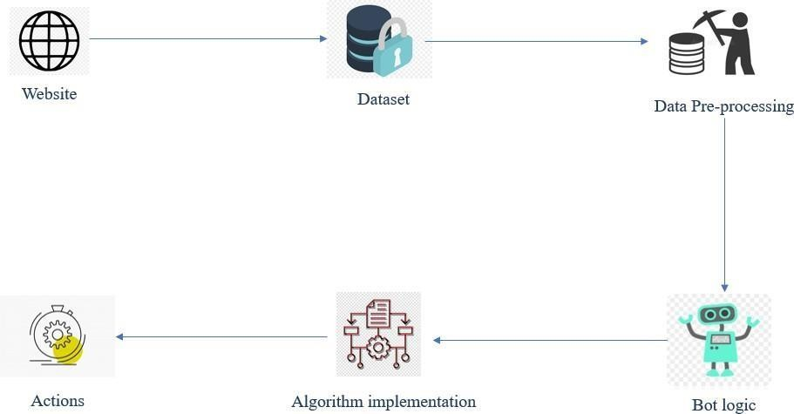

Fig 5.1 System Architecture

The system architecture defines the flow of the process. The website searches for the dataset and the data set is stored in the SQL database. There the data is pre-processed and bot logic is used to get the information about the process. Then finally the algorithm is implemented using bots and action taken.

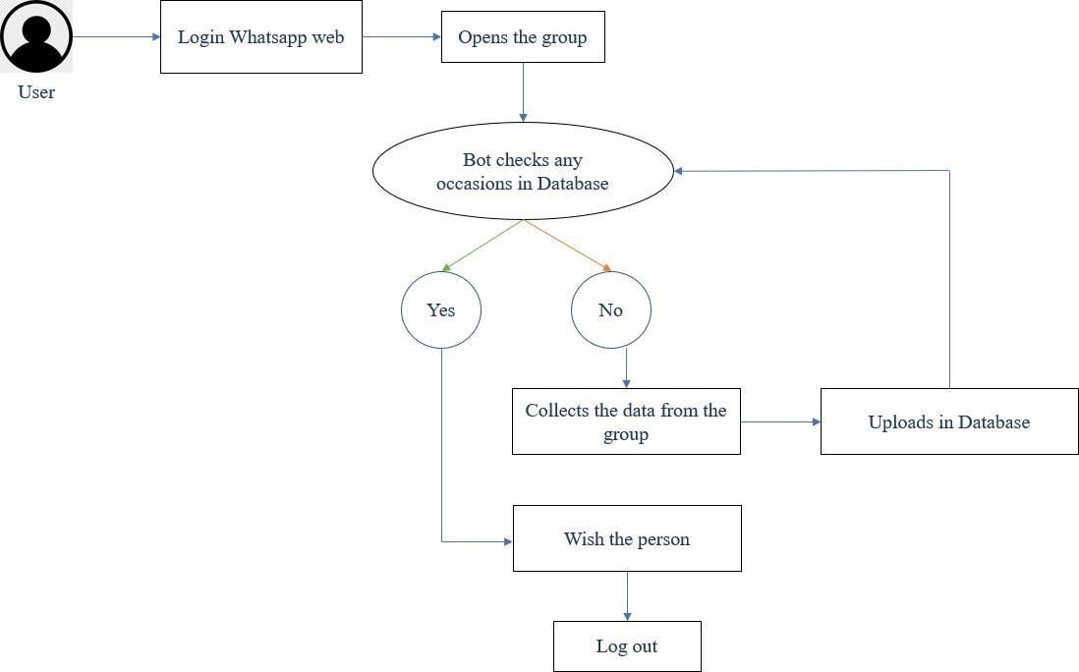

Fig 5.2 Architecture Diagram

The flow to the above diagram describes the process. The user logs in the Whatsapp Web. The website searches for the dataset and the data set is stored in the SQL database. And the bot spies by opening the group and checks the data received in the group. If yes wish the person if no then collect the data from the group and wish the person and automatically the bot logs out the Whatsapp Web.

# UML DIAGRAMS

A UML diagram is a diagram based on the UML (Unified Modeling Language) with the purpose of visually representing a system along with its main actors, roles, actions, artifacts or classes, in order to better understand, alter, maintain, or document information about the system.

# USE CASE DIAGRAM:

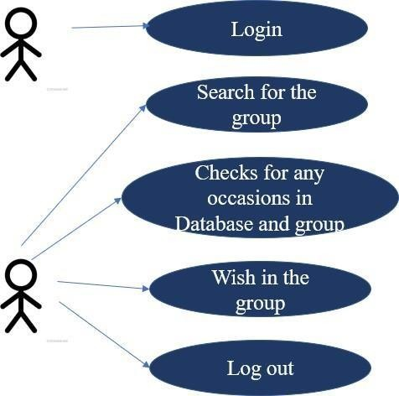

Fig 5.3 Use Case Diagram

Use-case diagrams describe the high-level functions and scope of a system. These diagrams also identify the interactions between the system and its actors. The use cases and actors in use-case diagrams describe what the system does and how the actors use it, but not how the system operates internally.

# CLASS DIAGRAM:

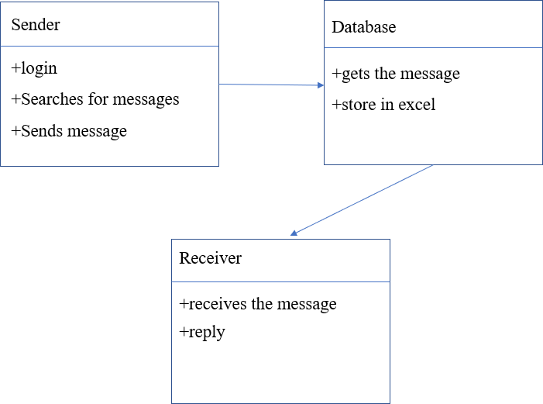

Fig 5.4 Class diagram

Class diagram is a static diagram. It represents the static view of an application. Class diagram is not only used for visualizing, describing, and documenting different aspects of a system but also for constructing executable code of the software application. Class diagram describes the attributes and operations of a class and also the constraints imposed on the system. The class diagrams are widely used in the modeling of object oriented systems because they are the only UML diagrams, which can be mapped directly with object-oriented languages. Class diagram shows a collection of classes, interfaces, associations, collaborations, and constraints. It is also known as a structural diagram

# ACTIVITY DIAGRAM:

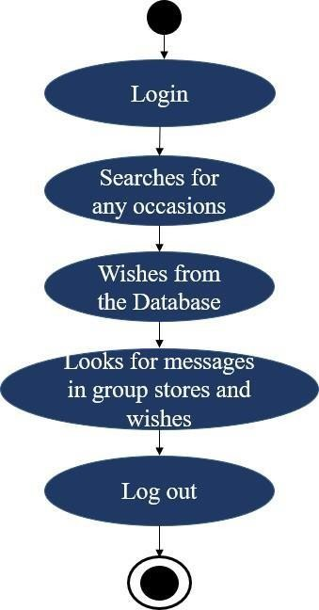

Fig 5.5 Activity diagram

Activity diagram is another important diagram in UML to describe dynamic aspects of the system. Activity diagram is basically a flowchart to represent the flow from one activity to another activity. The activity can be described as an operation of the system. The control flow is drawn from one operation to another. This flow can be sequential, branched, or concurrent. Activity diagrams deal with all type of flow control by using different elements such as fork, join etc.

# SEQUENCE DIAGRAM:

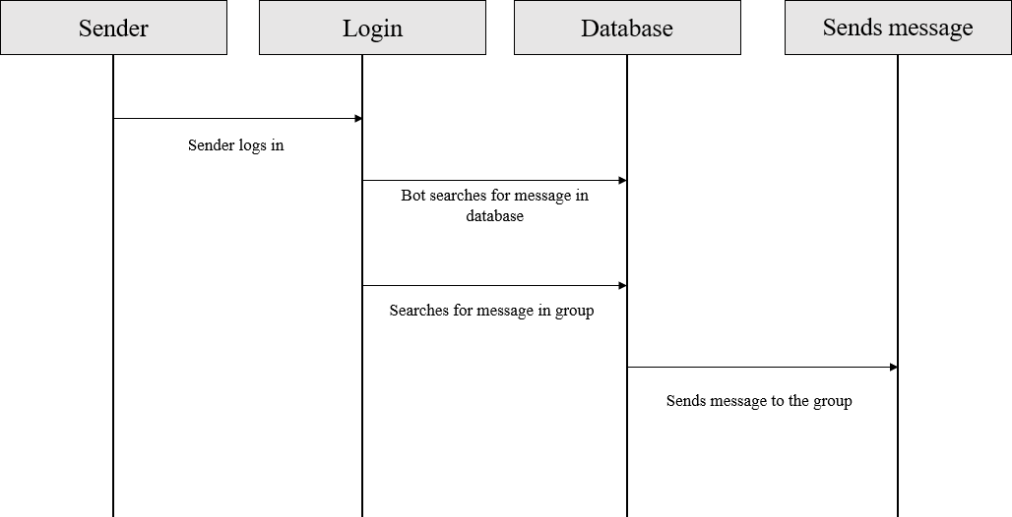

Fig 5.6 Sequence diagram

The sequence diagram represents the flow of messages in the system and is also termed as an event diagram. It helps in envisioning several dynamic scenarios. It portrays the communication between any two lifelines as a time-ordered sequence of events, such that these lifelines took part at the run time. In UML, the lifeline is represented by a vertical bar, whereas the message flow is represented by a vertical dotted line that extends across the bottom of the page. It incorporates the iterations as well as branching.

# E-R DIAGRAM:

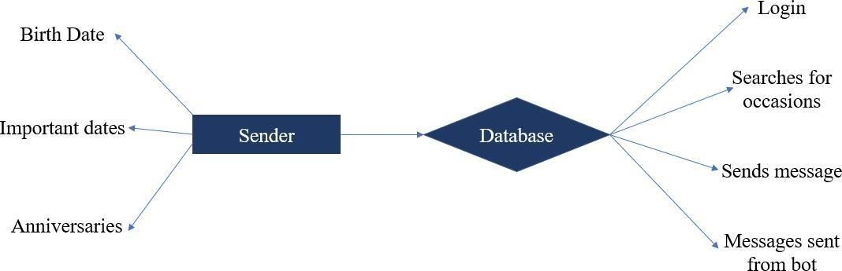

Fig 5.7 E-R diagram

An entity-relationship diagram (ERD) is a data modeling technique that graphically illustrates an information system's entities and the relationships between those entities. An ERD is a conceptual and representational model of data used to represent the entity framework infrastructure. For each data flow, at least one of the endpoints (source and / or destination) must exist in a process. The refined representation of a process can be done in another data- flow diagram, which subdivides this process into sub-processes. Entity relationship diagrams provide a visual starting point for database design that can also be used to help determine information system requirements throughout an organization. After a relational database is rolled out, an ERD can still serve as a referral point, should any debugging or business process re-engineering be needed later.

# CHAPTER 6 SYSTEM IMPLEMENTATION

* 1. **GENERAL:**

Blue Prism is a software company that develops industry [robotic process automation](https://www.simplilearn.com/tutorials/rpa-tutorial/what-is-rpa) [(RPA)](https://www.simplilearn.com/tutorials/rpa-tutorial/what-is-rpa) [software](https://www.simplilearn.com/tutorials/rpa-tutorial/what-is-rpa) that enables businesses to automate complicated, end-to-end procedures. Blue Prism created the Virtual Workforce Platform concept and is working on a robust, highly scalable, secure, and dependable enterprise Robotic Process Automation platform. Blue Prism's software complements traditional IT solutions by utilising an agile virtual workforce that adheres to rule- based business processes and interacts with systems similar to users. Blue Prism's RPA software solution automates processes that humans would otherwise perform manually or through extensive customization of existing IT systems.

Robotic Process Automation (RPA) is software technology that’s easy for anyone to use to automate digital tasks. With RPA, software users create [software robots](https://www.automationanywhere.com/rpa/software-bots), or “bots”, that can learn, mimic, and then execute rules-based business processes. RPA automation enables users to create bots by observing [human digital actions](https://www.automationanywhere.com/rpa/digital-workforce). Show your bots what to do, then let them do the work. Robotic Process Automation software bots can interact with any application or system the same way people do—except that RPA bots can operate around the clock, nonstop, much faster and with 100% reliability and precision. Resulting in a greater level of automation with significantly less investment and faster deployment.

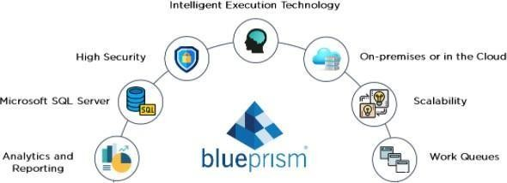

Fig 6.1 Blue Prism

# What is robotic process automation?

Rather, the “robot” in robotic process automation is software robots running on a physical or virtual machine.

“RPA is a form of business process automation that allows anyone to define a set of instructions for a robot or ‘bot’ to perform,” says Aaron Bultman, director of product at [Nintex](https://www.nintex.com/). “RPA bots are capable of mimicking most human-computer interactions to carry out a ton of error-free tasks, at high volume and speed.”

If that kind of automation technology sounds sort of, well, boring – especially compared to the Hollywood robots – that’s by design. RPA is ultimately about automating some of the most mundane and repetitive computer-based tasks and processes in the workplace. Think copy-paste tasks and moving files from one location to another, for example.

RPA automates everyday processes that once required human action – often a great deal of it performed in rote, time-consuming fashion. That’s also how RPA promises to boost efficiency for organizations.

# What Are the Benefits of RPA?

From better business outcomes, to improved employee engagement, there are many benefits of RPA. Below are six key advantages of adopting RPA.

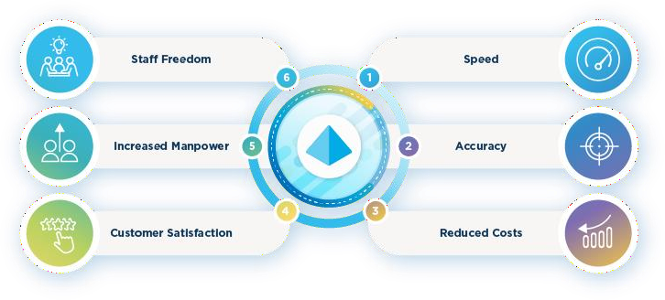

Fig 6.2 Benefits of RPA

From better business outcomes, to improved employee engagement, there are many benefits of RPA. Below are six key advantages of adopting RPA.

# Speed and Efficiency

Software bots work exceptionally quickly, especially compared to humans performing the same task. They drastically cut down processing time; a task that would take a human hour to complete can now be achieved in just minutes. And unlike a person rushing a task, this speed comes at no risk to the quality of the output.

Of course, these activities don't sit in isolation. RPA can also speed up and improve larger, complex processes and transform various operations throughout your organization.

# Accuracy Eliminates Human Error

Everyone makes mistakes and it's no surprise that errors creep in when people spend long hours on monotonous, repetitive tasks. But RPA bots will always perform perfectly. So long as they’re given the right instructions for their tasks, you’ll have uniform, predictable results every time.

# Reduced Costs

RPA of course has upfront charges and ongoing maintenance costs. Still, bots are far more productive and less expensive than the equivalent number of human workers required for the same results. Any time an RPA bot performs a task, it will be completed faster and more accurately than when performed by a person. This results in significant business savings and frees your people to perform other tasks.

# Improved Customer Satisfaction

Certain points in any customer experience (CX) journey will benefit from the 'human touch'. But for other areas, RPA offers many advantages for your customers. For instance, with robots working alongside employees, customers can expect quicker

response times.

Then there’s the indirect benefit of employee freedom. By taking care of laborious tasks, RPA gives your human customer service agents the time to manage more complex customer issues. They can focus on providing excellent personal responses for better customer satisfaction.

# Increased Output

RPA is an automation software that expands your workforce by giving you access to [digital workers](https://www.blueprism.com/resources/blog/the-future-of-the-digital-worker-planning-and-sequencing/). This new portion of your staff will be available 24 hours, seven days a week, with no vacation or sick days and no dips in productivity.

While they'll need some training, they will return far more hours back to the business than are put in. What’s more, they’ll free up other employees for more valuable work.

# Staff Freedom

RPA removes the burdens of monotonous jobs like data entry and invoice processing. Implementing back-end system automation simplifies workflows, liberating your employees traditionally tasked with these activities. These workers can now dedicate time to more challenging, creative and ultimately stimulating work.

RPA and [intelligent automation](https://www.blueprism.com/resources/rpa-and-automation-guides/intelligent-automation/) can do incredible things for your company. But your people and human creativity are still your strongest assets. Freeing your employees so they can strategically monitor, assess and refine your operations will be one of the greatest benefits of using RPA tools.

# MODULES:

* + - Data pre-processing
    - Bot logic
    - A* Algorithm
    - D* Algorithm
    - Deployment

# MODULES EXPLANATION:

* + 1. **DATA PRE-PROCESSING:**

Preprocessing simply refers to perform series of operations to transform or change data. It is transformation applied to our data before feeding it to algorithm. Data processing refers to perform operations on data to retrieve, transform, or change data, especially by computer. It is technique that is used to convert raw data into clean data set. In other words, whenever data is gathered from different sources, it is collected in raw format, which is not feasible for analysis. Then it converts raw format into readable format (graphs, documents, etc.), so that it can be interpreted by computers and utilized by employees throughout an organization. It transforms raw data into meaningful information. Services of data processing require skilled professionals to apply different technologies for analyzing and data processing. New technologies like ML (Machine Learning) is highly dependent upon data. As data is core of these technologies, so data has to be presented in way or format that makes it easier for the technologies to understand it. It is simply used for achieving better results from applying model. In ML, format of data has to be in proper manner. Some specified ML model needs specified format. For example, Random Forest algorithm doesn’t support NULL value. Therefore, to execute random forest algorithm, NULL values have to be managed from raw data set. The dataset should be formatted in such way that more than one ML and deep algorithm are executed in one dataset and then best out of them is selected.

# BOT LOGIC:

A bot is an app that users interact with in a conversational way, using text, graphics (such as cards or images), or speech. Azure Bot Service is a cloud platform. It hosts bots and makes them available to channels, such as Microsoft Teams, Facebook, or Slack. The Bot Framework Service, which is a component of the Azure Bot Service, sends information between the user's bot-connected app and the bot. Each channel can include additional information in the activities they send. Before creating bots, it's important to understand how a bot uses activity objects to communicate with its users. This diagram illustrates two activity types, conversation update and message, that might be exchanged when a user communicates with an echo bot. The Bot Framework Service sends a conversation update when a party joins the conversation. For example, on starting a conversation with the Bot Framework Emulator, you might see two conversation update activities (one for the user joining the conversation and one for the bot joining). To distinguish these conversation update activities, check who is included in the members added property of the activity. The message activity carries conversation information between the parties. In an echo bot example, the message activities are carrying simple text and the channel will render this text. Alternatively, the message activity might carry text to be spoken, suggested actions or cards to be displayed.

# A* ALGORITHM

The A* algorithm is a path search algorithm that is used to find the most optimal path between two points, i.e., with the smallest cost. Anytime A* Algorithm has a flexible time cost and can return the shortest path even if it is interrupted as it generates a non-optimal solution first and then optimizes it. This allows for faster decision making as the robot can build upon previous calculations instead of starting from scratch.

How Does It Work?

It does this by forming a ‘tree’ which extends in from the start node until the criteria for termination is triggered which means there is a less costly path available.

A 2D Grid is made with obstacles and a starting cell and target cells are pin-pointed. The algorithm defines a node’s ‘value’ by f which is the sum of parameters g (the cost of moving from the starting nodeto the node in question) and h (the cost of moving from the node in question to the target node).

# APPLICATIONS

A lot of games and web-based maps use this algorithm for finding the shortest path efficiently. It can also be used for mobile robots. You can also solve complex problems like the [Newton–Raphson](https://www.sciencedirect.com/topics/mathematics/newton-raphson-method) iteration applied to finding the square root of a number. It is also usedin trajectory problems to predict the motion and collision of an object in space.

# D* ALGORITHM

D*, Focused D* and D* Lite are incremental search algorithms to find the shortest path between two points. They, however, are a mixture of A* algorithms and new discoveries that allow them to add information to their maps for unknown obstacles. They can then recalculate route based on new information, much like the Mars Rover. How Does It Work?

The working of D* Algorithm is similar to that of A*, the algorithm first defines f, h and creates an open and closed list. After this, the D* Algorithm determines the current node’s g value using the g value of its neighboring nodes. Each neighboring node makes a guess about the current one’s g value and the shortest g value is adapted as the new g value.

Applications

D* and its variants are widely used for mobile robot and [autonomous](https://hashdork.com/system-design-of-an-autonomous-vehicle/) [vehicle](https://hashdork.com/system-design-of-an-autonomous-vehicle/) navigation. Such navigation systems include a prototype system tested on the Mars rovers Opportunity and Spirit and the navigation system that won the [DARPA](https://www.darpa.mil/about-us/timeline/darpa-urban-challenge) [Urban Challenge](https://www.darpa.mil/about-us/timeline/darpa-urban-challenge).

# DEPLOYMENT

Each module has a set of deployment properties associated with it by default; these are stored in the deployment descriptor file. If you want to specify different values for these properties, you can edit them directly in the descriptor file or in the IBM Integration Designer module deployment editor. Any changes that you directly make to module deployment properties in deployment descriptor files are typically overwritten when the deploy code is next regenerated. However, you can use the module deployment editor to specify and retain changes to module deployment properties. The module deployment editor saves your changes to a deployment side file, which is used to automatically update the module deployment

properties in the deployment descriptor files whenever the deploy code is regenerated or the module is installed on the server. Model deployment is the process of putting machine learning models into production. This makes the model’s predictions available to users, developers or systems, so they can make business decisions based on data, interact with their application (like recognize a face in an image) and so on. Model deployment is considered to be a challenging stage for data scientists. This is because it is often not considered their core responsibility, and due to the technological and mindset differences between model development and training and the organizational tech stack, like versioning, testing and scaling which make deployment difficult. These organizational and technological silos can be overcome with the right model deployment frameworks, tools and processes.

# RESULT AND DISCUSSION

When all these modules are applied to the process the outcome will be the desired output of the process. Thus the process of opening the Whatsapp Web and searching for the group and spying the group for any occasions on the particular date and store it in the Database SQL. Then by using the database we can wish automatically through a run time. This could be even scheduled and have a run time for running the process. Using the web version of the messenger does not limit the bot's capabilities, so this method is working for creating bots created for private use. The file system used in the program works more stable, since the main code does not change. At the moment, the bot has great potential, since the main functions were written. You can make almost anything out of them. As the next task, you can add the number of commands to the bot, for example, display the weather forecast, or display the schedule of a TV channel. Thus, a bot was developed that allows you to automate the process of sending congratulations to colleagues, and also has good potential for further work with WhatsApp.

# CHAPTER 7 TESTING

The purpose of testing is to discover errors. Testing is the process of trying to discover every conceivable fault or weakness in a work product. It provides a way to check the functionality of components, sub-assemblies, assemblies, and/or a finished product. It is the process of exercising software with the intent of ensuring that the Software system meets its requirements and user expectations and does not fail in an unacceptable manner. There are various types of tests. Each test type addresses a specific testing requirement.

# TYPES OF TESTING

* + - Unit testing
    - Integration testing
    - Functional testing
    - White box testing
    - Black box testing

# UNIT TESTING

* Unit Testing is a type of software testing where individual units or components of a software are tested. The purpose is to validate that each unit of the software code performs as expected.
* Unit testing is used to ensure that each modular component of the project is working.
* The smallest unit of the software design is the subject of unit testing.
* The mentioned project underwent a progressive examination of unit testing.
* The unit testing findings were good and encouraging.

# INTEGRATION TESTING

* Integration testing is a level of software testing where individual units are combined and tested as a group. The purpose of this level is to expose faults in the interaction between integrated units.
* Integration testing is a methodical methodology for building the software architecture while also running tests to detect faults related to the interface.
* Integration testing, in other words, is the comprehensive testing of the product's collection of modules.
* For the described project, a sequential analysis of Integration Testing was undertaken.
* The findings of the integration testing were positive and encouraging.

# FUNCTIONAL TESTING

It is a type of software testing whereby the system is tested against the functional requirements/specifications. Functions are tested by feeding them input and examining the output. Functional testing ensures that the requirements are properly satisfied by the application. This type of testing is not concerned with how processing occurs, but rather, with the results of processing. So, it tries to execute the test cases and compare the results and check the accuracy.

* Functional test cases included running the code with nominal input values for which the anticipated outputs were known, as well as boundary values and unusual values such as logically linked inputs, files with identical components, and empty files.
* For the project under consideration, a Functional Testing Sequential Analysis was carried out.
* The outcomes of functional testing were positive and encouraging.

# WHITE BOX TESTING

* White box testing is a software testing method in which the internal structure of the item is known to the tester. The tester chooses inputs to exercise paths through the code and determines the appropriate outputs.
* This kind of testing is also known as glass box testing.
  + By understanding the precise tasks that a product has been designed to accomplish, testing can be performed to verify that each function is completely operational while also looking for flaws in each function.
  + It is a test case design approach that derives test cases from the procedural design's control structure.
  + White box testing is used for basis path testing.
  + For the project under consideration, a sequential assessment of White Box Testing was carried out. White Box testing yielded positive and encouraging findings.

# BLACK BOX TESTING

* + - * Black box testing also known as behavioral testing is a software testing method in which the internal structure of the item being tested is known to the tester.
      * By understanding a product's internal operation, testing may be carried out to guarantee that “all gears mesh," that is, the internal operation operates according to 25 specifications and all internal components have been appropriately exercised.
      * For the described project, a sequential analysis of Black Box Testing was undertaken.

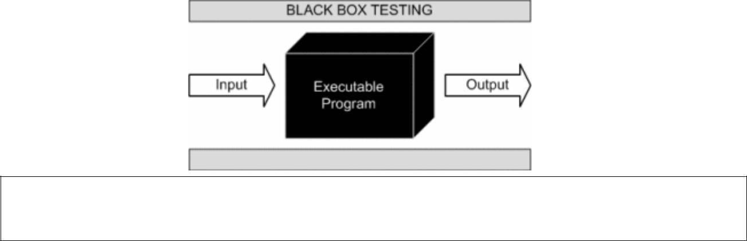

Fig 7.1 Black Box Testing

# TESTING STRATEGY

The basic strategy for the machine learning model testing includes various kinds of experimental steps etc., to achieve our outcome. The various testing is done such as unit, integration testing, etc. The main aim of the testing strategy is to check each and every part of our code is working properly or not. Before confirmation of our output to the user, we need to check the output twice for better.

# CHAPTER 8 CONCLUSION

* 1. **CONCLUSION**

Based on the analysis and the results of the experiment, a number of conclusions were drawn, including further areas of research. Nowadays, the popularity of messengers is growing, so it is important to automate processes and create bots. Using the web version of the messenger does not limit the bot's capabilities, so this method is working for creating bots created for private use. The file system used in the program works more stable, since the main code does not change. At the moment, the bot has great potential, since the main functions were written. You can make almost anything out of them. As the next task, you can add the number of commands to the bot, for example, display the weather forecast, or display the schedule of a TV channel. Thus, a bot was developed that allows you to automate the process of sending congratulations to colleagues, and also has good potential for further work with WhatsApp.

# FUTURE ENHANCEMENT

One of the main advantages of our WhatsApp automation tool is time-saving. You don't have to send each message to the group manually every time. It is enough to schedule the pre-written posts once a week, and Postoplan will automatically release them.

Scheduling messages on WhatsApp will allow you always to get your audience online. You don't have to wait for prime time to publish a post. Set the correct hour, and the service will make the release instead of you. This is especially useful if you and your clients live in different time zones.

Constantly keeping in touch with your audience through messages on WhatsApp will help you earn more money. Scheduled posts about new products and discounts will encourage customers to make purchases WhatsApp web automation will help increase your content quality since the posts created in advance and put on the deferred release are usually better than those written and published at the last moment.

Using RPA Automation in Blue Prism we can easily automate messages in direct message or in groups. Schedule a time and running the process can make the process run automatically and send the messages. Thus we can automate through RPA.

# APPENDIX

**9.1 Process 1**

Bot launches WhatsApp Web application in Chrome and navigates to the specified group to fetch today’s messages. It stores all the messages in the database. Stores the messages into bot’s memory. Storing the data is storing the data into the database of the system done in SQL.

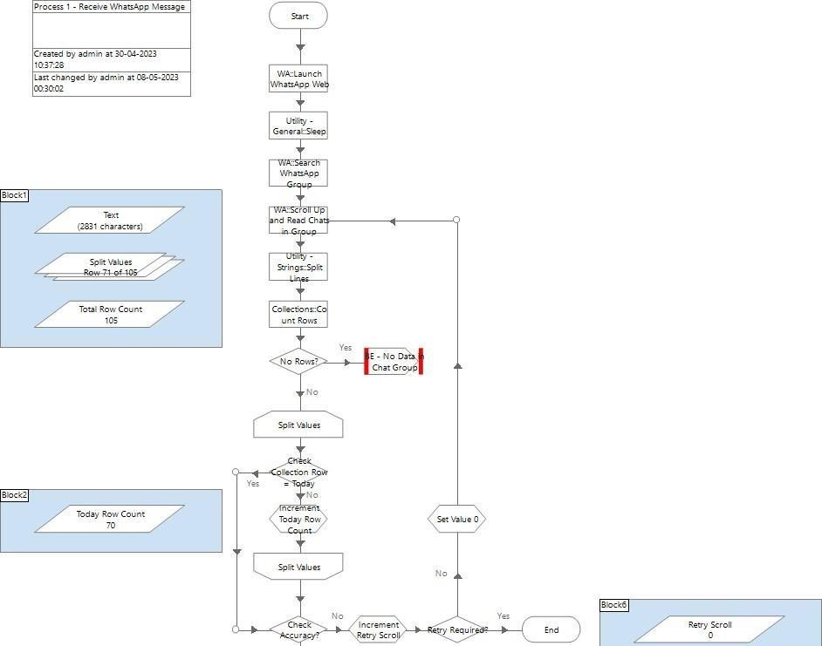

Fig 9.1 Bot launches and store the data

**9.1.1 Sample Output for Process 1:** WhatsApp Messages:

The bot spies for the messages in the group scrolls till today and stores the data in the database. It notes all the data and occasion and store it in the database i.e. in Excel sheet.

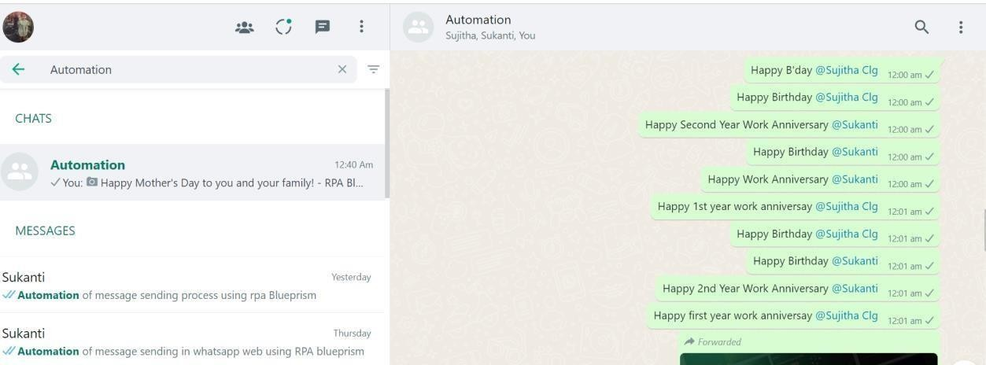

Fig 9.1.1 Spying the messages

**9.1.2 Blue Prism Memory:**

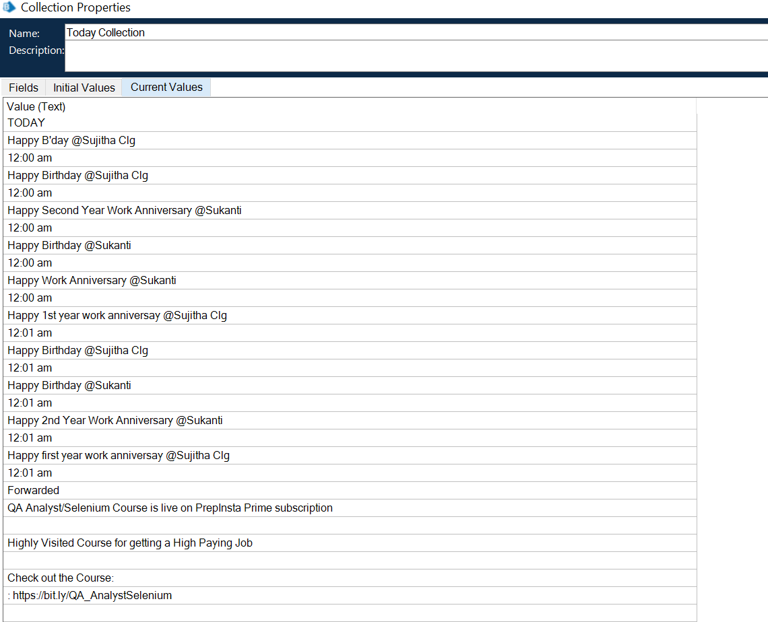

Fig 9.1.2 Blue Prism Memory

Bot fetches Employee Details (such as Name) from birthday messages received on group for today. It stores in the memory of the database generally it is used as SQL. And the data are checked if needed to be corrected. The data contains even the time and date so that it stores and wishes on the correct time.

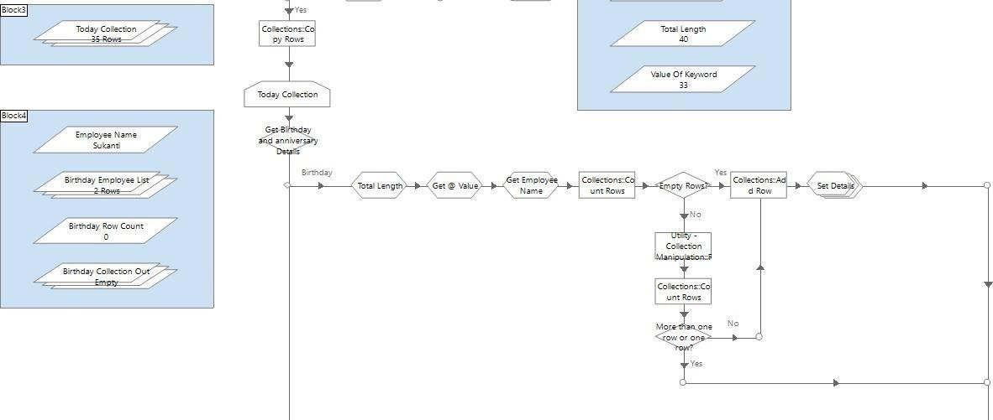

Fig 9.1.3 Storing Birthday messages

Sample Output for Database 1:

Blue Prism Output:

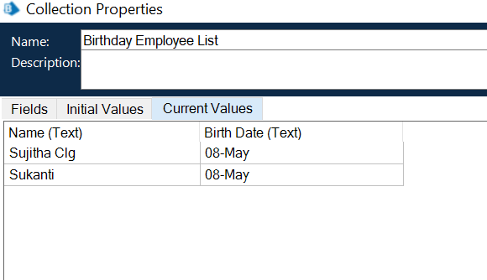

Fig 9.1.4 Database 1

Bot fetches Employee Details (such as Employee Name) from work anniversary messages received on group for today. It is same as birthday messages. It stores in the memory of the database generally it is used as SQL. And the data are checked if needed to be corrected. The data contains even the time and date so that it stores and wishes on the correct time.

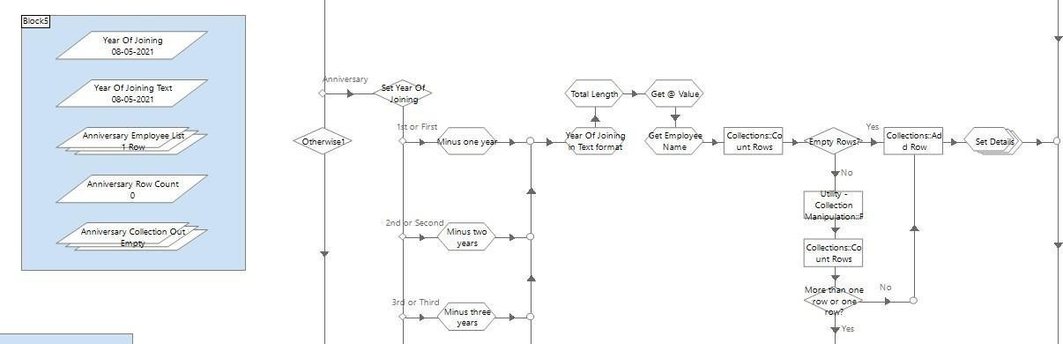

Fig 9.1.5 Storing Work Anniversary messages

Sample Output for Database 2:

Blue Prism Output

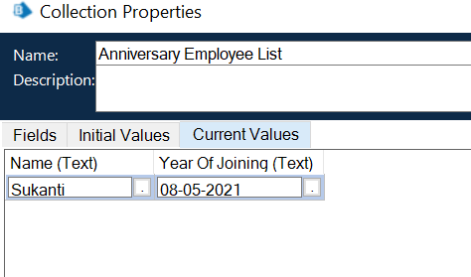

Fig 9.1.6 Database 2

Bot fetches existing details from data file (Excel) and compares with the outputs fetched by the bot. If the data from output matches the data from excel, then bot ignores. Else bot will add the output details in the excel sheet.

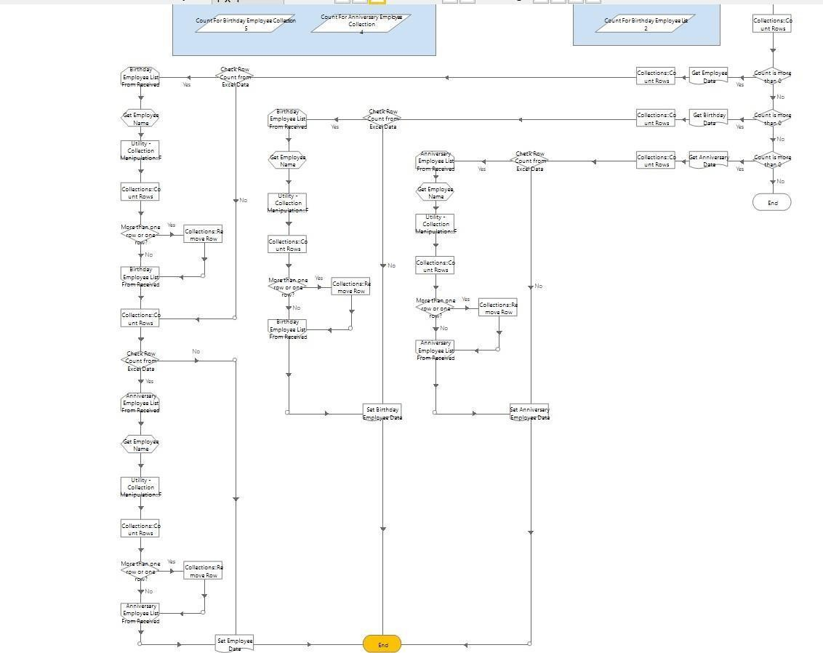

Fig 9.1.7 Storing in excel sheet

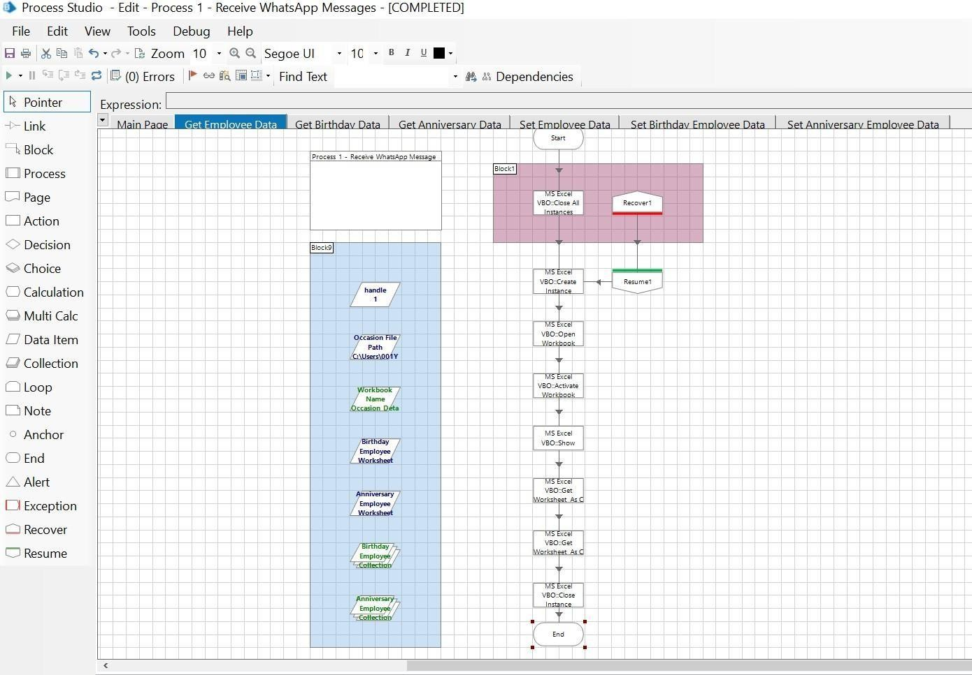

Fig 9.1.8 Process flow 1

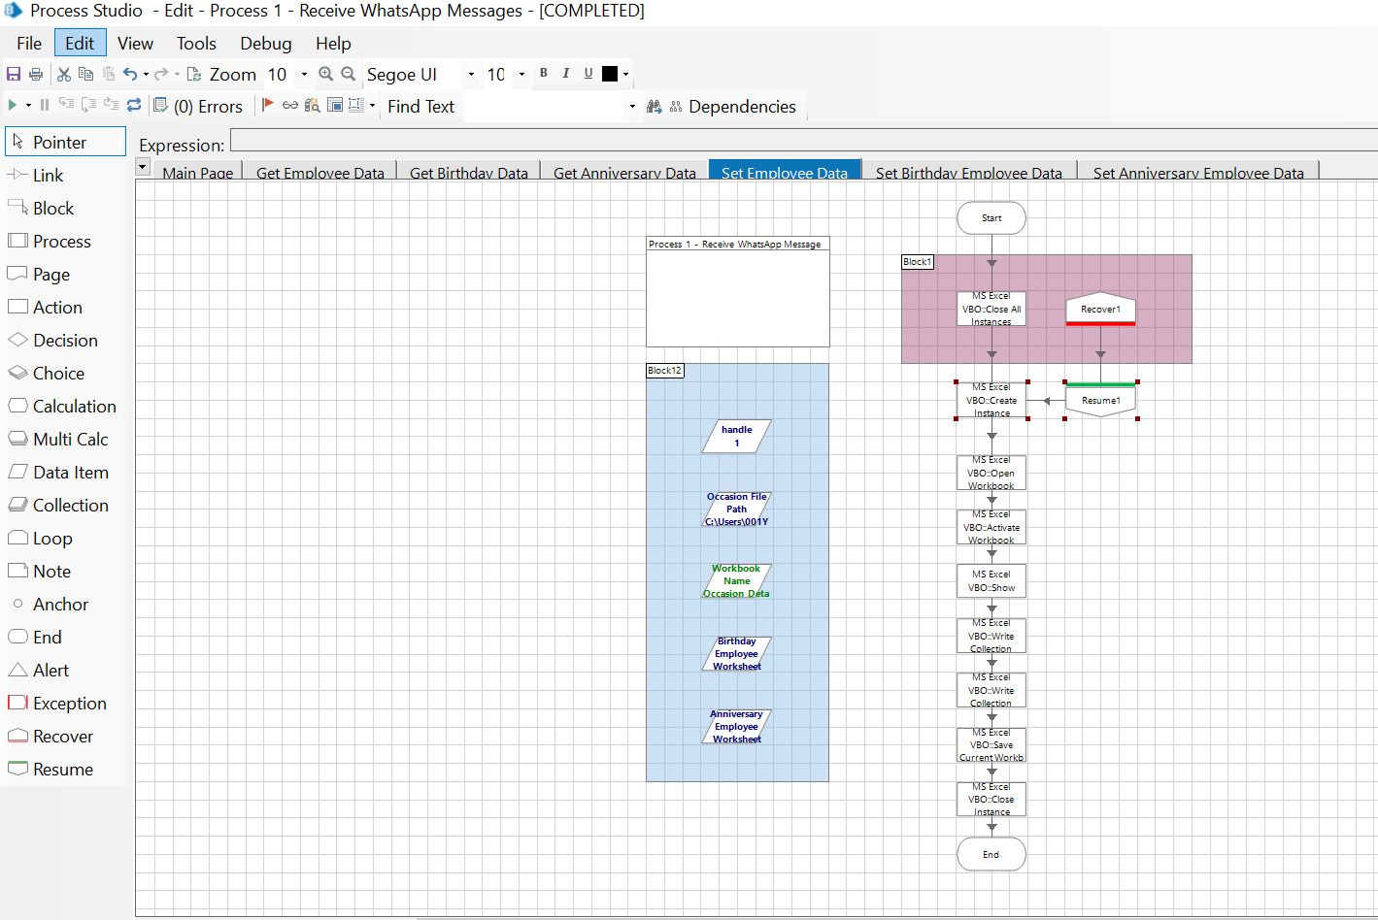

Fig. 9.1.9 Process flow 2

Sample Output:

Excel Sheet As Input:

These are the excel sheets before storing the data.

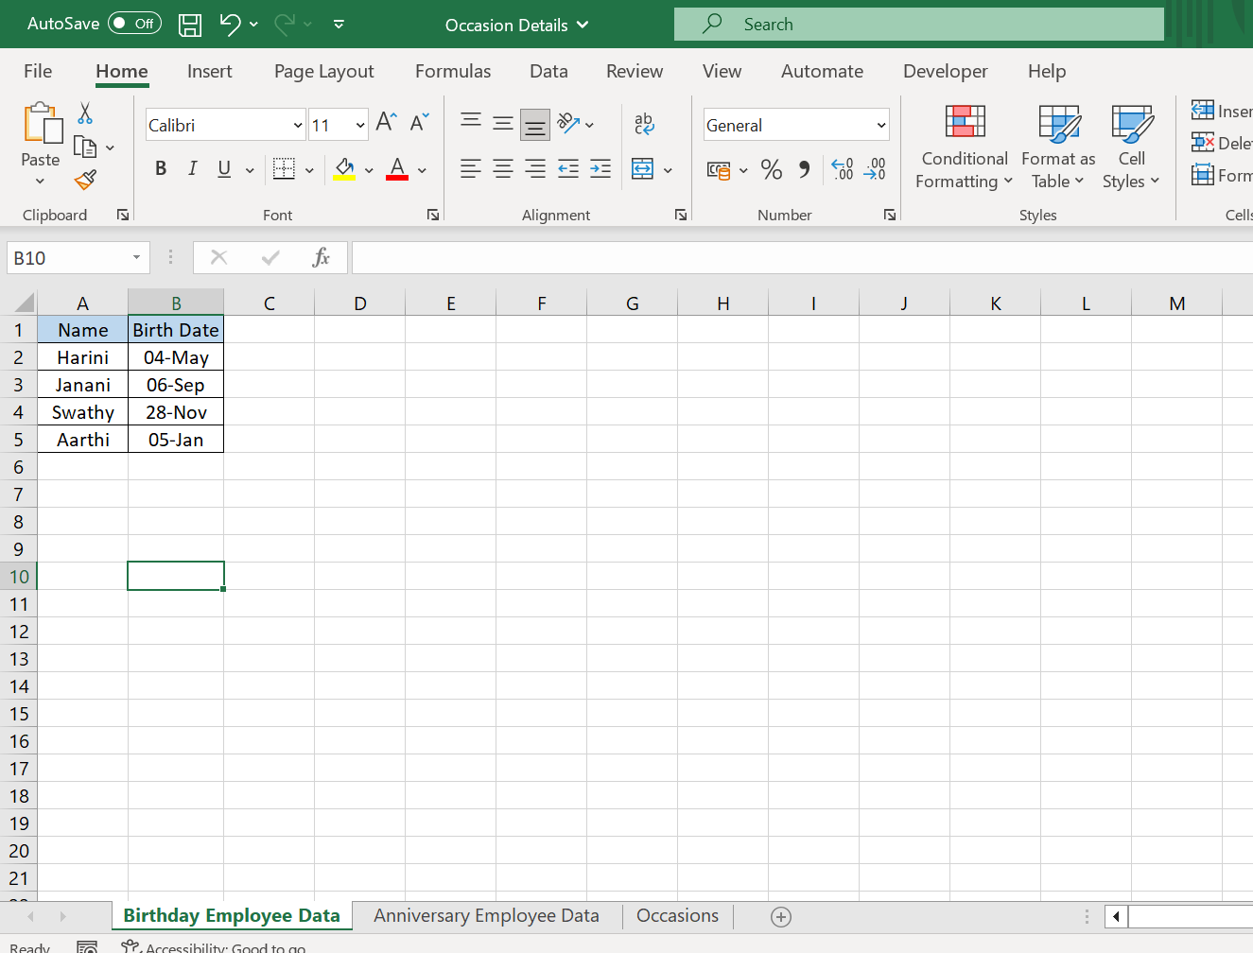

Fig 9.2.0 Excel sheet 1

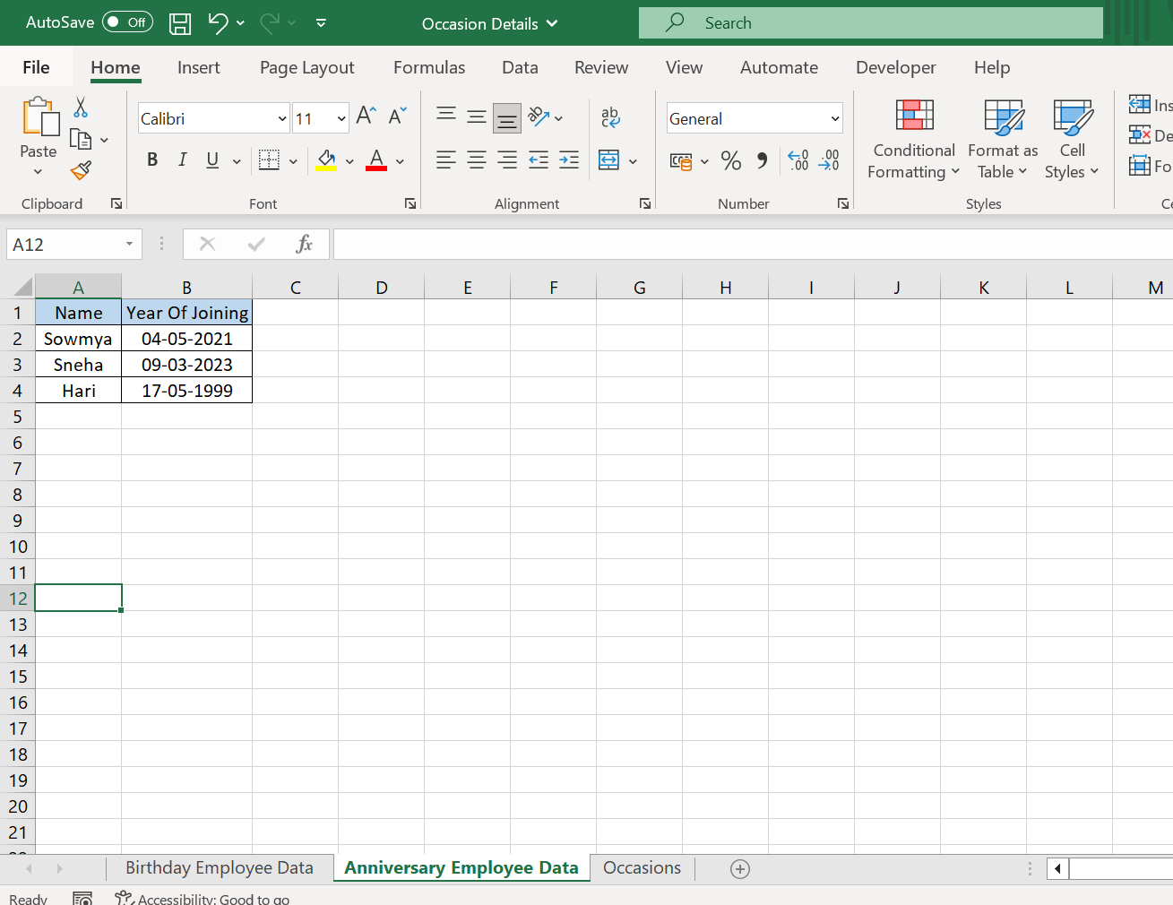

Fig 9.2.1 Excel sheet 2

Excel Sheet As Output:

These are the excel sheets after storing the data.

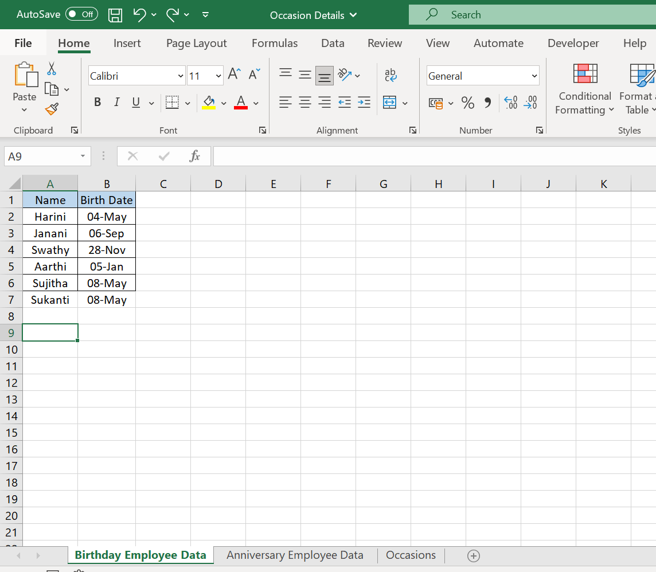

Fig 9.2.2 Excel sheet 1

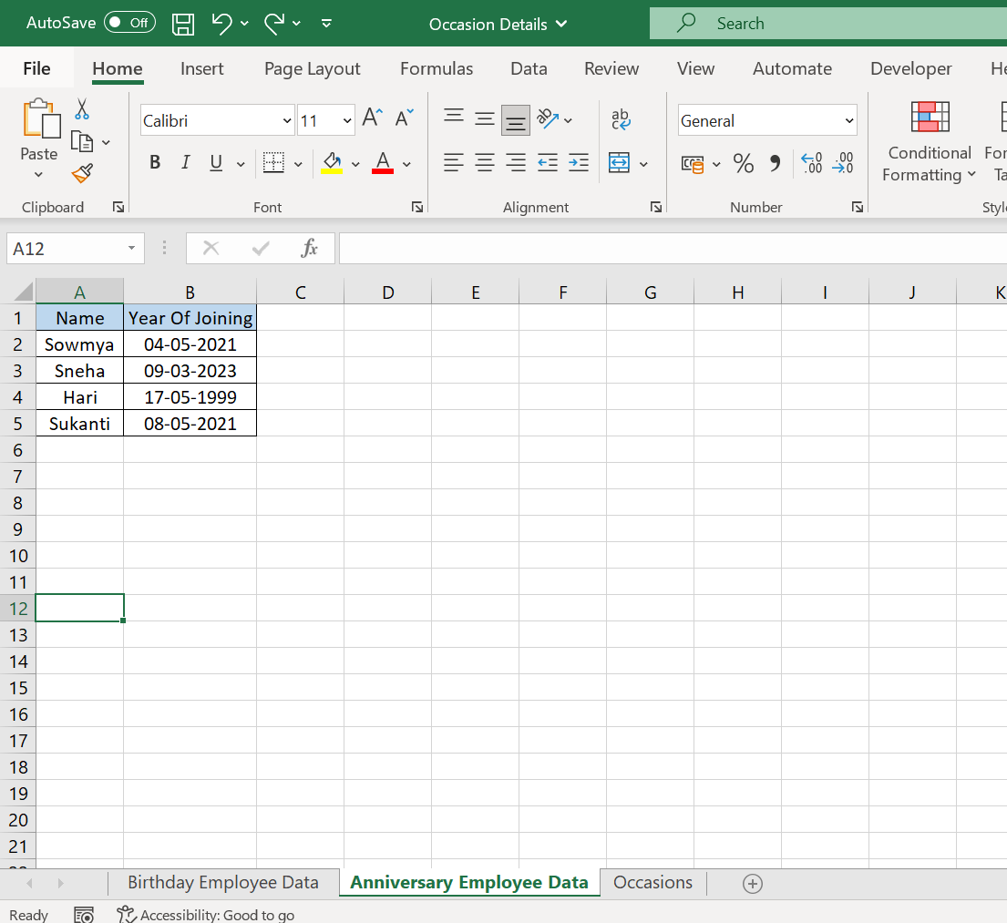

Fig 9.2.3 Excel sheet 2

# 9.3 Process 2

Bot fetches employee and national occasion details from input excel into bot’s memory. And looks for the group and messages in the group.

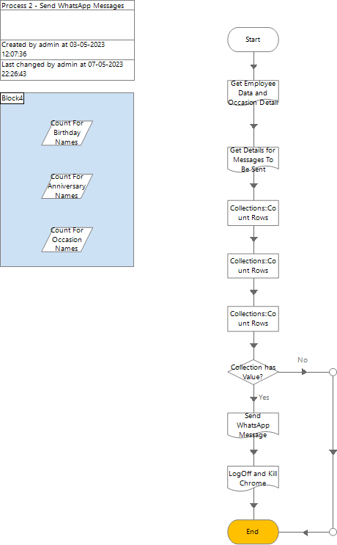

Fig 9.3 Process 2

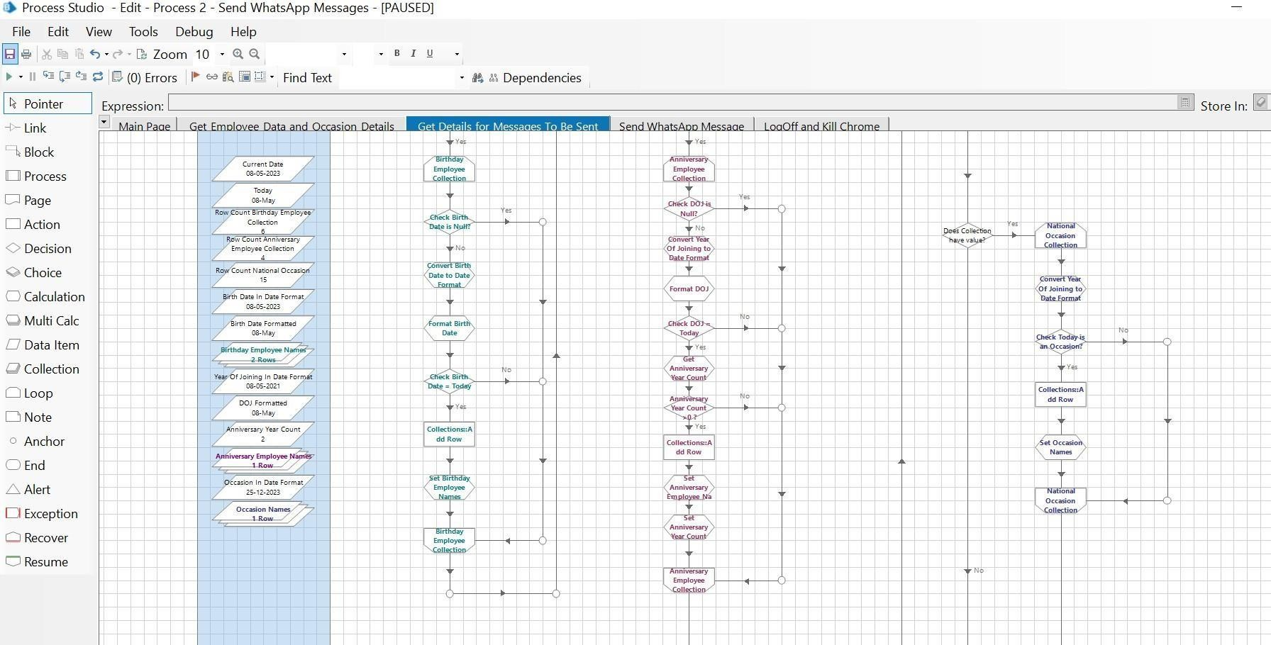

Fig 9.3.1 Flow of process 2

Excel Sheet As Output:

These are the excel sheets after storing the data.

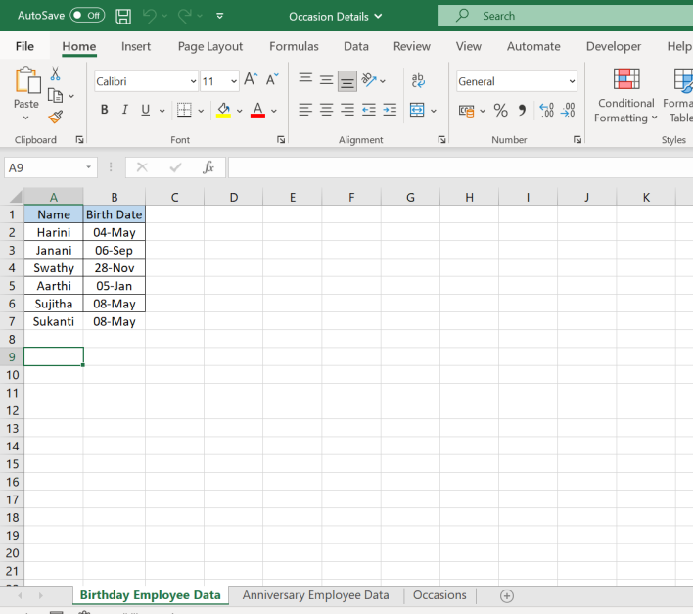

Fig 9.3.2 Excel sheet 1

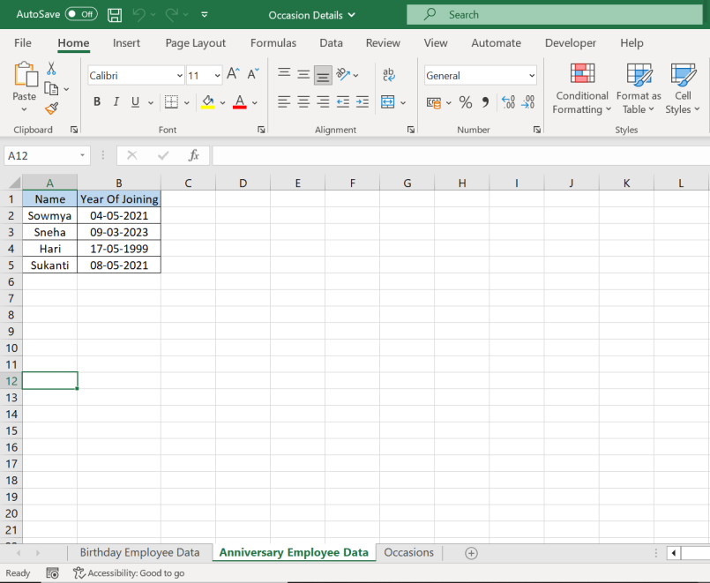

Fig 9.3.3 Excel sheet 2

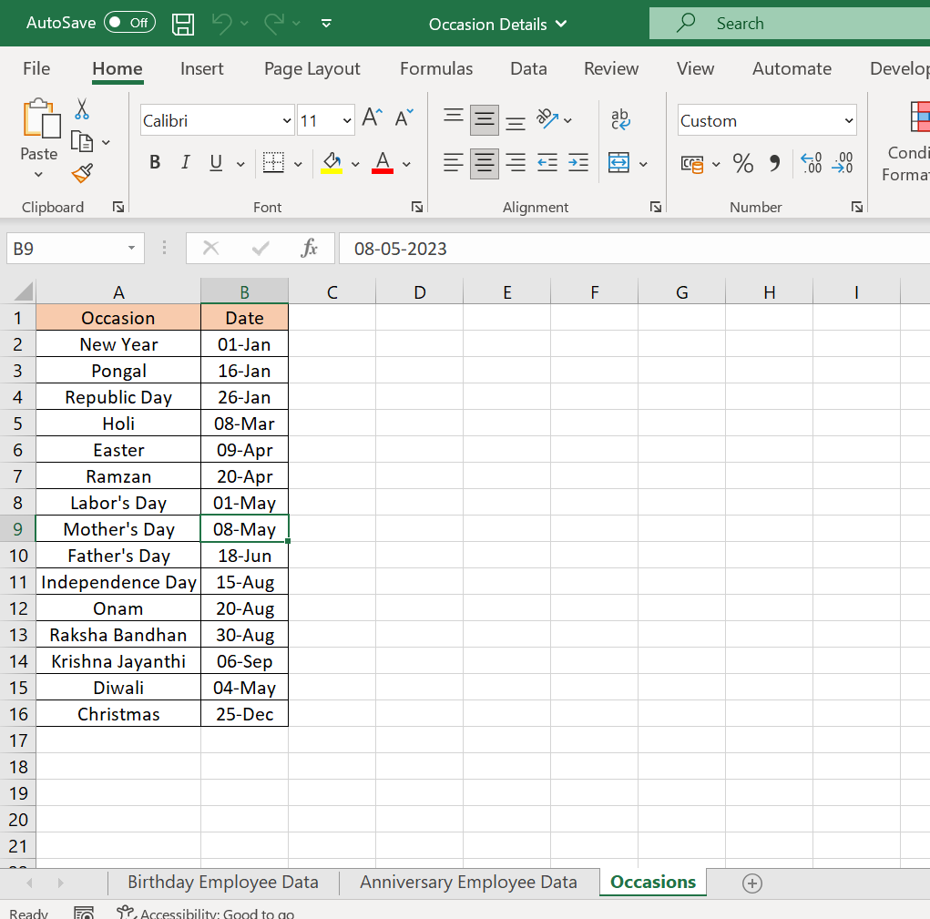

Fig 9.3.4 Occasion holidays

Bot sends the messages for Birthday/Work Anniversary and on National Occasions.

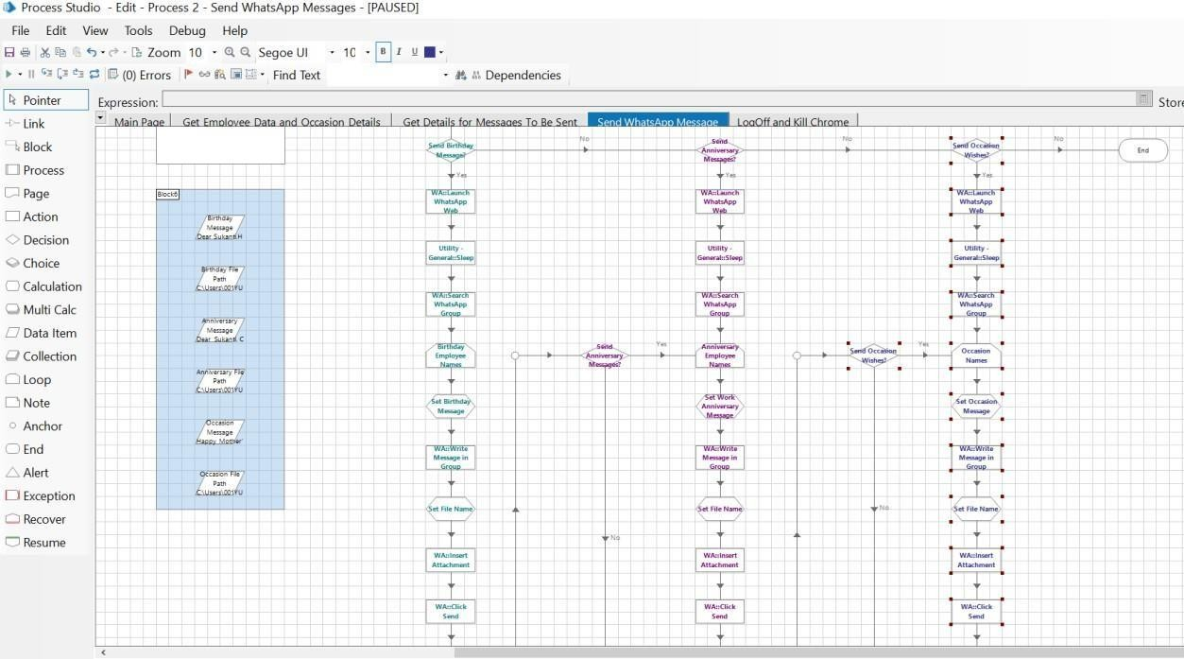

Fig 9.3.5 Bot sends message

**9.4 Output :**

9.3.1 Blue Prism Messages on WhatsApp:

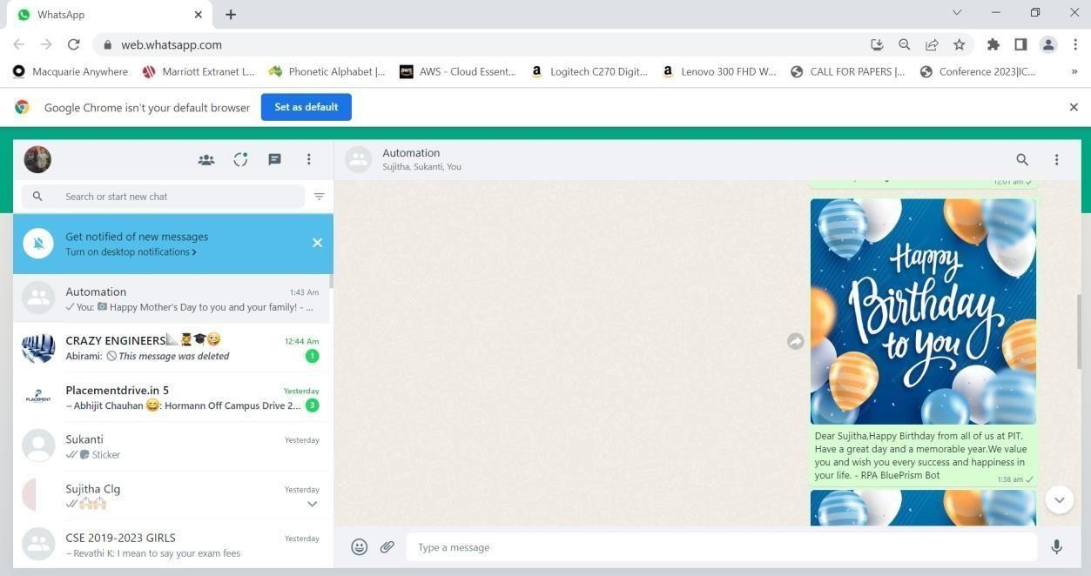

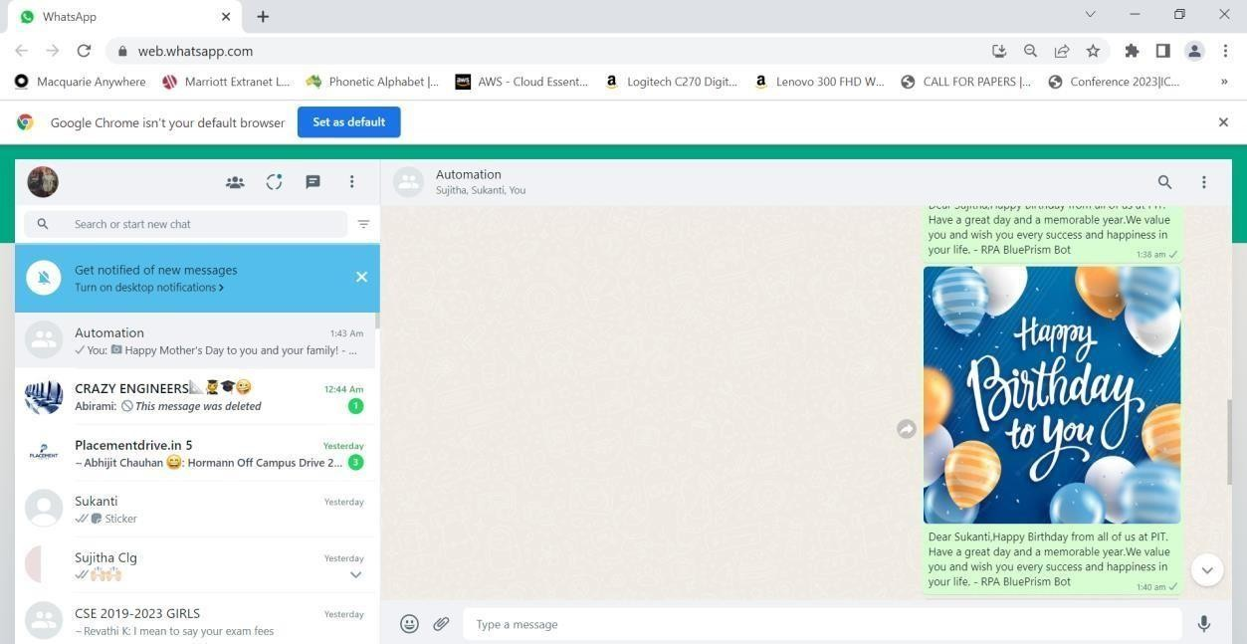Fig 9.4.1 Message 1

Fig 9.4.2 Message 2

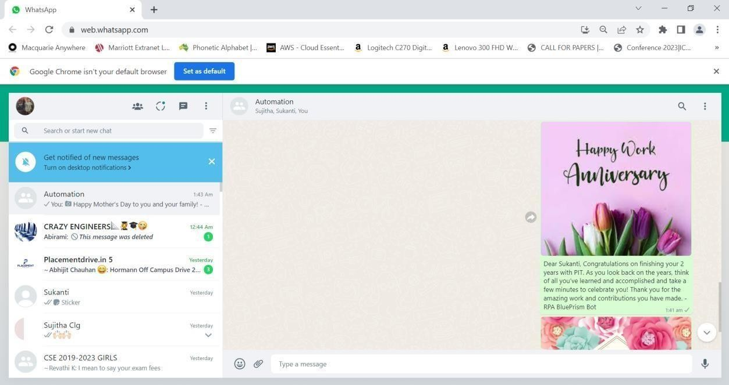

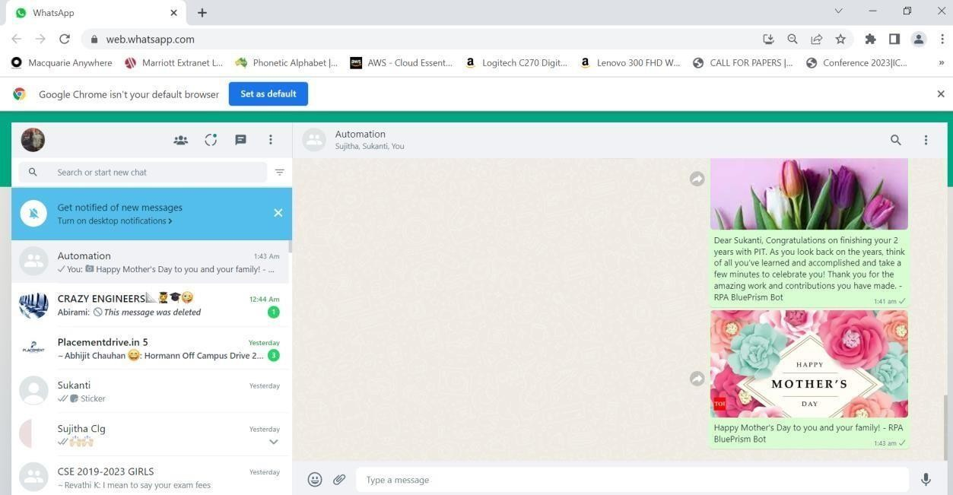Fig 9.4.3 Message 3

Fig 9.4.4 Message 4

**REFERENCES**

[1]. Messina Chris. 2016 will be the year of conversational commerce //A Medium Corporation. URL: https://medium.com/chris-messina/2016- will-be-the-year-of- conversational-commerce-1586e85e399 (accessed: 25.09.2020) (in Russ.)

[2].https://[www.sostav.ru/publication/messendzhery-vs-sotsseti-kto-vblizhajshee-](http://www.sostav.ru/publication/messendzhery-vs-sotsseti-kto-vblizhajshee-) vremya-pobedit-v-reklamnoj-skhvatke26339.html(accessed: 25.09.2020) (in Russ.)

[3]. Why do you need your own WhatsApp bot? //Bot creators. URL: https://botcreators.ru/blog/pochemu-vam-nuzhen-chat-bot-v-whatsappobzor- platformy- dlya-bota/ (accessed: 25.09.2020) (in Russ)

[4]."Productivity pains: 90repetitive tasks", 2017, [online] Available: [https://www.snaplogic.com/press-releases/productivity-pains-90-workers-burdened-](https://www.snaplogic.com/press-releases/productivity-pains-90-workers-burdened-boring-repetitive-tasks) [boring-repetitive-tasks](https://www.snaplogic.com/press-releases/productivity-pains-90-workers-burdened-boring-repetitive-tasks).

[5]. "Automation in the workplace 2017", 2017, [online] Available: <https://www.smartsheet.com/sites/default/files/smartsheet-automation-workplace.pdf>.

[6]. R. Kumar, "Future for scientific computing using python", International Journal of Engineering Technologies and Management Research2, pp. 30-41.

[7]. M. Sharma and R. Angmo, "Web based automation testing and tools", International Journal of Computer Science and Information Technologies, vol. 5, no. 1, pp. 908-912, 2014.

[8]. M. Chui, J. Manyika and M. Miremadi, "Four fundamentals of work-place automation", McKinsey Quarterly, vol. 29, no. 3, pp. 1-9, 2015.

[9]. C. C. Durham, E. A. Locke, J. M. Poon and P. L. McLeod, "Effects of group goals and time pressure on group efficacy information-seeking strategy and performance", Human Performance, vol. 13, no. 2, pp. 115-138, 2000.

[10]. C. Jain and R. Kaluri, "Design of automation scripts execution application for selenium web driver and test ng framework", ARPN J Eng Appl Sci, vol. 10, pp. 2440-2445, 2015.